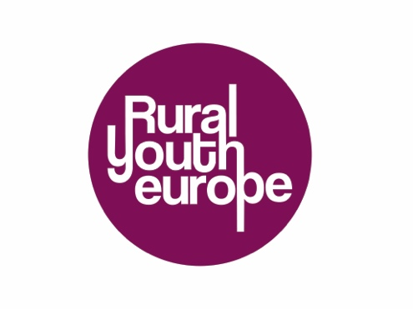
Submission Form
Rural Youth Project of the Year 2018
Project name:
Name of organisation:
Contact person for the project (Name, email and phone number):
Project description (max 300 words):
- Why should your project be the Rural Youth Project of the year 2018?
- What was the goal?
- Where did the idea come from?
- Who was involved?
- What was the impact of this project on the community?
- How many people were involved in the project (approximately)?

The selection for the projects for public voting will be made by the Rural Youth Europe board. The online voting will open 15th March and the winning project will be announced at the beginning of April 2018.

Please send the completed application to your organisation.
Rural Youth Europe member organisations: Please submit applications and presentations by February 28th 2019 to office@ruralyoutheurope.com

